ESOA Member Profile

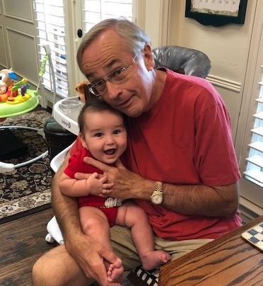

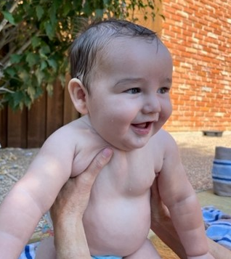

Business:
1) When did you start your career in the recruiting/search field?

Started my search business in 2000, same year I left Quaker Oats/PepsiCo. I was very involved with recruiting during my corporate career also, except I was on the other side of the desk. I interviewed and hired hundreds of professionals and thousands of hourly employees. I became close business friends with several search firm owners during my corporate career.

2) Why did you decide on a career in the recruiting/search field?

After leaving my corporate roles in HR and Plant Management at age 50, I still had a lot of gas in the tank to start my new career. Bill Stenetski and I met at an SMU course on starting and running your own business. Bill and I hit it off and he invited me to an IRG meeting which has now morphed into ESOA. I met a lot of other recruiters there, enjoyed their company and all their wild recruiting stories and the rest is history.

3) Briefly describe your company and specialization:

Dixon Associates specializes in Food Manufacturing. That’s what I knew best from my years with Quaker Oats so the decision to stay in food was easy.

4) Describe any interesting success you had in our business, i.e., a placement story, winning a new client, or whatever.

I am particularly proud of my relationship with one private equity Company that started relatively early in my search career. It developed because I knew someone (an X Quaker Oats employee) who was their CHRO. The company was just getting started and my CHRO friend asked me to fill a CIO position as a favor (no fee just good will). I had never worked an IT position and haven’t since. I got lucky and filled it in about 5 weeks and didn’t collect a dime. Apparently, they appreciated it and as they grew, I became their “go to” recruiter. I was fortunate to make 163 placements with them over the course of about 9 years (which I did get paid for). When they were bought by Goldman Sachs my relationship with them ended. It was a great ride! In terms of proudest placement, I filled a VP of Manufacturing position for another private equity Company in Chicago, whose CEO was also an old Quaker Oats alum. He called me, we met, I received a 5-bullet point job description on a napkin, no contract or anything, just a verbal agreement. This led to a $61K fee, the largest of my career. Moral of the story: Recruiting is a relationship business. To get started in the business you don’t have to be a great recruiter if you know a lot of people and have a good line of BS. The technical recruiting skills will come later!

Personal:

5) What city/state were you born and raised?

Hornell, NY (Western NY State)

6) What are your hobbies?

Used to play a little golf but I spent so much time in the woods looking for my ball that no one wanted to play golf with me. Now my hobbies include trying to keep on the good side of my wife of 46 years, playing with our 6-month-old grandson, pistol shooting (you can never have too many guns) and lots of volunteer work and gardening.

7) Favorite Movie(s):

I’m not a big movie guy but Kim forces me to see a movie now and then. We just saw Elvis which was great. Also liked Redeeming Love and Bohemian Rhapsody. My wife has informed me that we are going to see Where the Crawdads Sing next week.

8) Fun fact about yourself, i.e., something about you, either past or present worth sharing:

I have always been very impatient and in a hurry. In my corporate roles supervising others I was known as “Do It Now Tom”! Not everyone liked my “get the lead out” persona but I believe my work ethic, and urgency paid off both for me and the business. I have backed off a lot from my intensity to get stuff done and have transferred that energy to be a better husband, father, and grandfather. My little grandson Gavin has captured my heart and frankly I’m never too busy to be with him!

